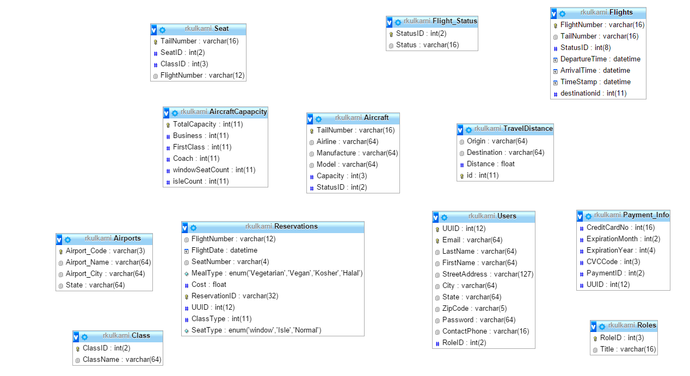

Nandakishore Tokala, Rohan Kulkarni, Majesh Reddy Salla